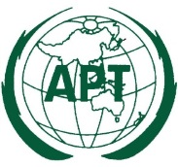 | ASIA-PACIFIC TELECOMMUNITY
 | Coordination Meetings of APT during RA-23 and WRC-23
 | 13 November – 16 December 2023, Dubai, United Arab Emirates

agenda of the 3rd APT coordination meeting for WRC-23

Room: D2, Dubai WTC
Time: 12:10 – 13:30 Hours, 27 November 2023

- Approval of Agenda

- Report from the Agenda Item Coordinators (Issues to be discussed at the coordination meeting)

  - AI1.2
  - AI1.4
  - AI1.10
  - AI1.11 Issue A
  - AI7 Topic A
  - AI7 Topic B
  - AI10 (MSS below 4GHz)
  - AI10 (Space weather sensor)
  - AI10 (Regulatory framework for non-GSO FSS)

- Further arrangements for Agenda Item 10
  - Discussion on the topics under AI10 which APT did not make a position,
- the study of regulatory framework for which WRC and scope of study, if WRC-27
  - Review AI10 Coordinators

- Information on the planning of AI Coordination meeting

- Any other business

__________

