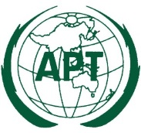 | ASIA-PACIFIC TELECOMMUNITY
 | Coordination Meetings of APT during RA-23 and WRC-23
 | 13 November – 16 December 2023, Dubai, United Arab Emirates

agenda of the 7th APT coordination meeting for WRC-23

Room: D2, Dubai WTC
Time: 12:20 – 13:30 Hours, 1 December 2023

- Approval of Agenda

- Report from the Agenda Item Coordinators (Issues to be discussed at the coordination meeting)

  - AI1.1
  - AI1.2
  - AI1.4
  - AI1.11 Issue C
  - AI10 (IMT Issues)
  - AI10 (PAI 2.3: FSS allocation in [43.3-45.5 GHz])

  - AI10 (SAR and RDS in 10 GHz)
  - Res.655 (WRC-15)
  - AI10 (Narrow band MSS)
  - AI10 (NGSO regulatory framework)

- Arrangements for AI Coordination Meetings

- Next APT Coordination meeting

- Any other matters

__________

