PFD limits for SRS space-to-space

Dynamic study
DRS 160W
Test point – 123E 24N
Inclination 51.6 deg
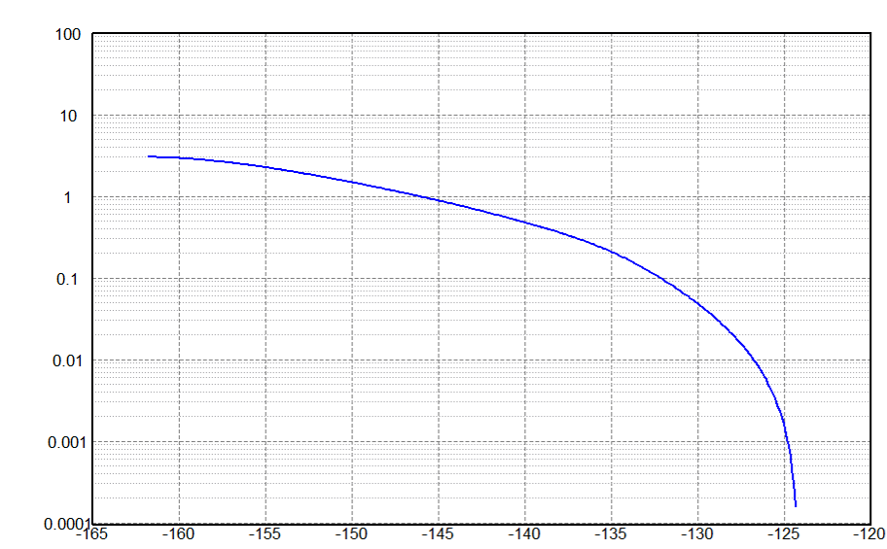
Inclination 97 deg
