Dear APT Members,

The following issues will be addressed at today's APT Coordination Meeting and seek guidance thereafter:

1. Band 6 (10-10.5GHz in Region 2) MOD RR No. 5.481

During this morning session, some countries (including R1 countries) proposed to add their names to RR No. 5.481, shown below.
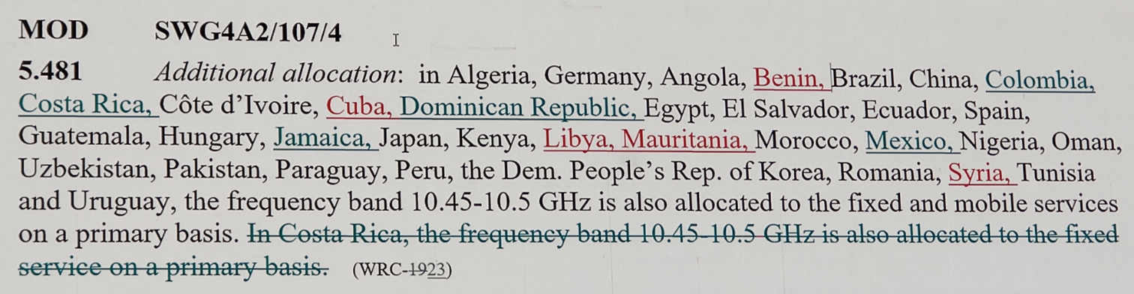

APT Members are kindly invited to express views to this new issue, to see if any action needs to be taken from APT.

