 | World Radiocommunication Conference (WRC-23)  Dubai, 20 November - 15 December 2023 |  | 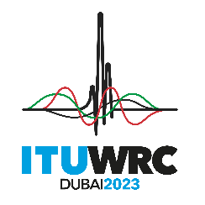
WORKING GROUP 5B |  | DT 1.18-E
 |  | 21 November 2023
 |  | Original: English
SUB-WORKING GROUP 5B4
[DARFT] FIRST REPORT TO Working Group 5B
Agenda item 1.18
1.18 to consider studies relating to spectrum needs and potential new allocations to the mobile-satellite service for future development of narrowband mobile-satellite systems, in accordance with Resolution 248 (WRC-19);

Jennifer MANNER
Chair, Sub-Working Group 5B4
E-mail: SWG5B4wrc23@lists.itu.int

NOC SWG5B4//1
ARTICLES

NOC SWG5B4//2
APPENDICES

SUP SWG5B4//3
RESOLUTION 248 (WRC-19)
Studies relating to spectrum needs and potential new allocations to the mobile-satellite service in the frequency bands 1 695-1 710 MHz, 2 010-2 025 MHz, 3 300-3 315 MHz and 3 385-3 400 MHz for future development of
narrowband mobile-satellite systems

